**CA-1**

*QUESTION -1*

*CODE –*

package CA1;

import org.openqa.selenium.By;

import org.openqa.selenium.WebDriver;

import org.openqa.selenium.chrome.ChromeDriver;

import org.openqa.selenium.chrome.ChromeOptions;

import io.github.bonigarcia.wdm.WebDriverManager;

public class CA11

{

public static void main( String[] args ) throws InterruptedException

{

ChromeOptions co = new ChromeOptions();

co.addArguments("--remote-allow-origins=*");

WebDriverManager.chromedriver().setup();

WebDriver driver = new ChromeDriver(co);

driver.get("https://www.amazon.in/Samsung-Galaxy-Ultra-Cream-Storage/dp/B0BRSLH4B5/ref=sr_1_5?keywords=samsung%2Bs23%2Bultra%2B5g&qid=1683193039&sprefix=samsung%2Caps%2C332&sr=8-5&th=1");

driver.manage().window().maximize();

String title = driver.getTitle();

String etitle = "Samsung Galaxy S23 Ultra 5G (Cream, 12GB, 256GB Storage) : Amazon.in: Electronics";

System.out.println(title);

if(title.equals(etitle)) {

System.out.println("Title is matching");

}

else {

System.out.println("Title Mismatch");

}

driver.findElement(By.xpath("//*[@id=\"add-to-cart-button\"]")).click();

Thread.sleep(5000);

System.out.println("Is item added to cart: +present");

driver.get("https://www.amazon.in/gp/cart/view.html/ref=dp_atch_dss_cart?");

Thread.sleep(5000);

driver.findElement(By.xpath("//*[@value=\"Delete\"]")).click();

Thread.sleep(2000);

String removeText = driver.findElement(By.xpath("//*[@id=\"sc-active-cart\"]/div/div[1]/div/h1")).getText();

String extext = "Your Amazon Cart is empty.";

if(removeText.equals(extext)) {

System.out.println("Product is removed");

}

driver.get("https://www.amazon.in/Samsung-Galaxy-Ultra-Cream-Storage/dp/B0BRSLH4B5/ref=sr_1_5?keywords=samsung%2Bs23%2Bultra%2B5g&qid=1683193039&sprefix=samsung%2Caps%2C332&sr=8-5&th=1");

driver.findElement(By.xpath("//*[@id=\"add-to-cart-button\"]")).click();

Thread.sleep(2000);

driver.get("https://www.amazon.in/gp/cart/view.html/ref=dp_atch_dss_cart?");

Thread.sleep(5000);

driver.findElement(By.xpath("//*[@id=\"a-autoid-0-announce\"]")).click();

driver.findElement(By.xpath("//*[@id=\"quantity_2\"]")).click();

Thread.sleep(2000);

System.out.println("Quantity is changed.");

driver.findElement(By.xpath("//*[@id=\"sc-buy-box-ptc-button\"]/span/input")).click();

Thread.sleep(1000);

String sign = driver.getTitle();

System.out.println(sign);

String esign = "Amazon Sign In";

if(sign.equals(esign)) {

System.out.println("Success");

}

else {

System.out.println("Failure");

}

driver.findElement(By.xpath("//*[@id=\"ap_email\"]")).sendKeys("kavinadityatr@gmail.com");

driver.findElement(By.xpath("//*[@id=\"continue\"]")).click();

driver.findElement(By.xpath("//*[@id=\"ap_password\"]")).sendKeys("Pendoor6/");

driver.findElement(By.xpath("//*[@id=\"signInSubmit\"]")).click();

}

}

*OUTPUT –*

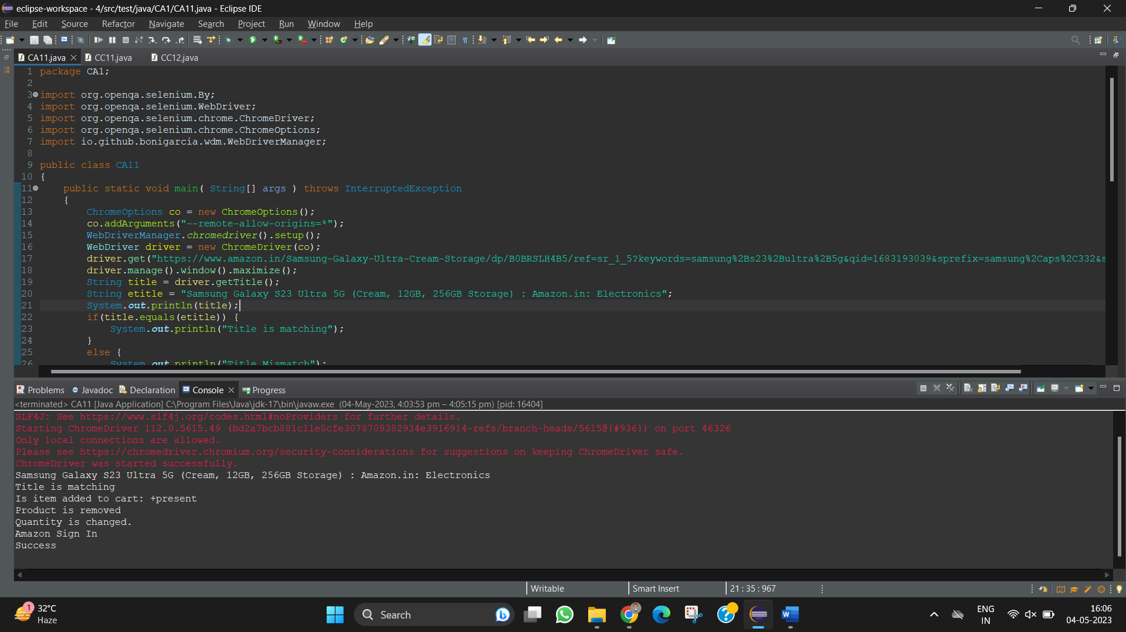

*QUESTION -2*

*CODE –*

package CA1;

import org.openqa.selenium.By;

import org.openqa.selenium.WebDriver;

import org.openqa.selenium.WebElement;

import org.openqa.selenium.chrome.ChromeDriver;

import org.openqa.selenium.chrome.ChromeOptions;

import io.github.bonigarcia.wdm.WebDriverManager;

public class CA12 {

public static void main(String[] args) throws InterruptedException {

// TODO Auto-generated method stub

ChromeOptions co=new ChromeOptions();

co.addArguments ("--remote-allow-origins=*");

WebDriverManager.chromedriver().setup ();

WebDriver driver=new ChromeDriver(co);

driver.get ("https://www.amazon.in/");

driver.manage().window().maximize() ;

String currentTitle=driver.getTitle();

System.out.println(currentTitle);

String expectedTitle="Online Shopping site in India: Shop Online for Mobiles, Books, Watches, Shoes and More - Amazon.in";

if(currentTitle.equals(expectedTitle)) {

System.out.println("Title Matched");

}

else {

System.out.println("Title not Matched");

}

WebElement txtBoxl=driver.findElement(By.xpath("//*[@id=\"twotabsearchtextbox\"]"));

txtBoxl.sendKeys("Oneplus 11R");

driver.findElement(By.xpath("//*[@id=\"nav-search-submit-button\"]")).click();

//displaying 5 products

String txt1=driver.findElement(By.xpath("//*[@id=\"search\"]/div[1]/div[1]/div/span[1]/div[1]/div[3]/div/div/div/div/div/div[2]/div/div/div[1]/h2/a/span")).getText();

System.out.println(txt1);

Thread.sleep(10000);

String txt2=driver.findElement(By.xpath("//*[@id=\"search\"]/div[1]/div[1]/div/span[1]/div[1]/div[4]/div/div/div/div/div/div[2]/div/div/div[1]/h2/a/span")).getText();

System.out.println(txt2);

String txt3=driver.findElement(By.xpath("//*[@id=\"search\"]/div[1]/div[1]/div/span[1]/div[1]/div[5]/div/div/div/div/div/div[2]/div/div/div[1]/h2/a/span")).getText();

System.out.println(txt3);

String txt4=driver.findElement(By.xpath("//*[@id=\"search\"]/div[1]/div[1]/div/span[1]/div[1]/div[9]/div/div/div/div/div/div[2]/div/div/div[1]/h2/a/span")).getText();

System.out.println(txt4);

String txt5=driver.findElement(By.xpath("//*[@id=\"search\"]/div[1]/div[1]/div/span[1]/div[1]/div[11]/div/div/div/div/div/div[2]/div/div/div[1]/h2/a/span")).getText();

System.out.println(txt5);

//filter

driver.findElement(By.xpath("//*[@id=\"p_n_feature_eight_browse-bin/14267636031\"]/span/a/div/label/i")).click();

}

}

*OUTPUT –*

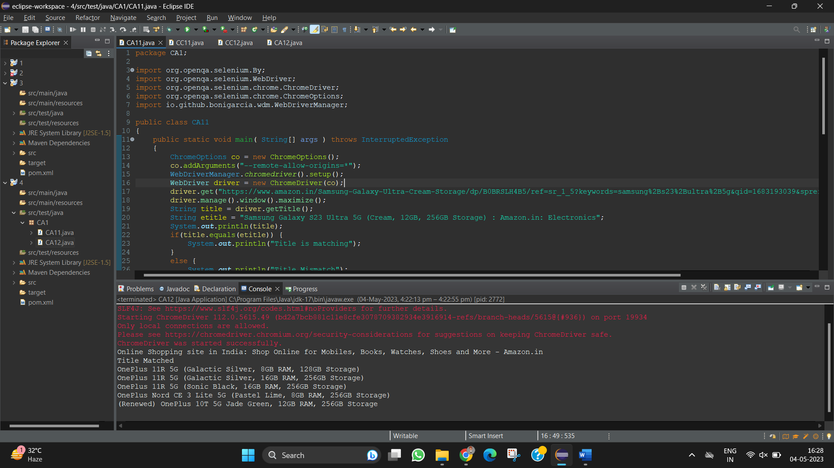

*QUESTION -3*

*CODE –*

package CA1;

import org.openqa.selenium.By;

import org.openqa.selenium.WebDriver;

import org.openqa.selenium.WebElement;

import org.openqa.selenium.chrome.ChromeDriver;

import org.openqa.selenium.chrome.ChromeOptions;

import org.openqa.selenium.interactions.Actions;

import io.github.bonigarcia.wdm.WebDriverManager;

public class CA13

{

public static void main(String[] args) throws InterruptedException {

WebDriverManager.chromedriver().setup();

WebDriver driver;

ChromeOptions co=new ChromeOptions();

co.addArguments("--remote-allow-origins=*");

driver=new ChromeDriver(co);

driver.navigate().to("https://www.amazon.in/");

Actions actions = new Actions(driver);

WebElement element = driver.findElement(By.xpath("//*[@id=\"nav-link-accountList\"]/span"));

actions.moveToElement(element).perform();

Thread.sleep(3000);

WebElement link = driver.findElement(By.xpath("//*[@id=\"nav-al-your-account\"]/a[1]/span"));

link.click();

Thread.sleep(3000);

WebElement yourorder=driver.findElement(By.xpath("//*[@id=\"a-page\"]/div[2]/div/div[2]/div[1]/a/div/div"));

yourorder.click();

Thread.sleep(3000);

WebElement searchbox=driver.findElement(By.xpath("//*[@id=\"ap_email\"]"));

searchbox.sendKeys("kavinadityatr@gmail.com");

WebElement yesbutton=driver.findElement(By.xpath("//*[@id=\"continue\"]"));

yesbutton.click();

Thread.sleep(3000);

WebElement passw=driver.findElement(By.xpath("//*[@id=\"ap_password\"]"));

passw.sendKeys("Pendoor6/");

WebElement signin=driver.findElement(By.xpath("//*[@id=\"signInSubmit\"]"));

signin.click();

}

}

*OUTPUT –*

